BUSINESS REQUIREMENTS DOCUMENTS

Question Management System (QMS)

16-Nov-17

Divergent Technologies Ltd.



Contents

Introduction ---------------------------------------------------------------------------------------------------------2

Project Summary ---------------------------------------------------------------------------------------------------2

Features --------------------------------------------------------------------------------------------------------------2

System Administrator --------------------------------------------------------------------------------------------2

Recruitment Manager ---------------------------------------------------------------------------------------------2

Head of HR -----------------------------------------------------------------------------------------------------------3

User Management -------------------------------------------------------------------------------------------------3

Administrator --------------------------------------------------------------------------------------------------- ---5

Examinee **---------------------------------------------------------------------------------**---------------------------6

Reporting ------------------------------------------------------------------------------------------------------------7

Security ---------------------------------------------------------------------------------------------------------------8

Survey ----------------------------------------------------------------------------------------------------------------8

Conclusion ----------------------------------------------------------------------------------------------------------8

Introduction:

Question Management System (QMS) is a web based application developed by Divergent Technology Ltd. for conducting Online Tests. QMS can be automated to test the candidate’s ability on any topic or subject in terms of time and space complexities. It can be used by both IT & Non-IT Sectors.

Project Summary:

QMS is being used for Management of Assembly Question. It is linked with Online Answering System which is a web based application. Concerned departments check their questions on-line and submit their answers accordingly.

Features:

Question Management System (QMS) system is fully dynamic role base system. For operational purpose we describe 6 different roles.

* + - 1. **System Administrator**
      2. **Recruitment Manager**
      3. **Head of HR**
      4. **User Management**
      5. **Administrator**
      6. **Examinee**

1. **System Administrator:**

Will play different type of role such as user creation, edit or deletion with Maker & Checker role segregation, Password set / re-set

1. **Recruitment Manager:**
2. To configure question paper for different examinations – Title, Venue, Score, Duration, nos. of question under each category, where to consider negative marking, scoring weight allocation, Random vs. Fixed, Must be Answered, etc.
3. To schedule an examination
4. To nominate script checker and exam invigilator under each examination
5. To select nos. of question set for each examination
6. To approve examination result upload
7. To see/download individual user's result
8. To see/download team/department wise result
9. To see/download exam wise result
10. To search individual candidate result by providing candidate ID
11. To search examination result by providing examination ID
12. **Head of HR:**
13. To approve or reject submitted questions for creating the question pool
14. To approve or reject question paper configuration
15. To cancel or change a scheduled examination
16. To approve or reject script checker and exam invigilator nomination under each examination
17. Subject Matter Experts: To develop questions under each category
18. Recruitment Assistant - Question:
19. To generate (only in PDF format) and take print-outs of question paper as per approved nos. of sets under scheduled examination (Question paper should only be available for view or print-out just 1 day before examination day)
20. Recruitment Assistant – Result:
21. To upload examination result for different sets under each examination
22. System Audit:
23. To generate audit log (no create or edit permission should be there)
24. Candidate:
25. Candidate will beable see MCQ type exam result after completing the exam. This option could be configurable.
26. **User Management:**

* Admin can create a new user account using the QMS Platform portal or can implement user registration in application.
* Admin can update/block/delete any user using the QMS Platform portal or you can implement user registration in application.
* QMS have fully dynamic role management system. User can create as many roles as want by providing specific permissions.
* User could be assigned any role from defined role.
* User Management Provides the searching facilities based on various factor such as User, User Types, Customers, User Profile
* Application also provides excel export for User, User Types, Customers, User Profile
* You can also export the report into User, User Types, Customers, User Profile
* User can change their password using mail or admin have the privilege to reset any user password.
* Admin can create any admin group. Admin group have specific number of user.
* Generating “Sets” for same exam.
* PDF for printing Hardcopy question papers.
* For online examinations, small quiz / assessment should be generated after certain slides as exam preparation.
* Upon successful completion, completion / training certificate with scanned signatures can be generated in PDF.
* Notification through email and SMS – Exam Date Alerts, Question Set Generation, Question Addition to the central depository, Training Nomination, Completion, etc.
* Batch examination through online – tabulation, result sheet, circulation, etc.
* Maker & Checker role segregation.

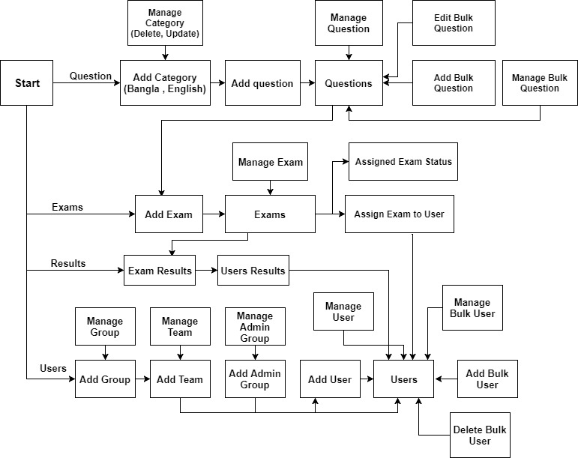

Fig: Administrator activist

1. **Administrator:**

Administrator role will play the vital role of this system. Bellow options will be available for administrator role:

1. **Question**

* User enters into the site using the login credentials.
* User will be able to create MCQ or descriptor questions.
* User has services like Create, update, and upload the questions;
* User can upload questions in category/subject wise manner and choose the difficulty level of question.
* If any modifications are needed in the particular question, administrator can update the questions.
* User will be able to change the status of the question or delete it if required.
* User can preview the Exam Page.
* User setup the exam environment. Sets how many questions from each subtopic for generating the exam paper.
* Question search will be available with wide range of criteria.
* **Question papers would be barcoded.**
* **Setup of “Must Be Answered” and “Any X nos.”**

1. **Exams**

* User will be able to create exam by providing exam details (Ex. Exam Title, Type-MCQ/ Descriptive, Duration, Marks etc.)
* User can select number of question form each category. Randomly question will be tagged to created exam.
* There are two different types of exams, MCQ or descriptor questions.
* User has services like Create, update, and upload the exams;
* User will be able to assign exam to any QMS user/ user team/ user department.
* **Negative marking**
* **Weighted average scoring**
* User will be able to change the status of the question or delete it if required.
* Report is available in different formats such as Selection report (i.e., Total report with qualified and unqualified details.) and Duration report.

1. **Result**

* User will be able see/download individual user’s result.
* User will be able see/download team/department wise result.
* User will be able see/download exam wise result.
* Candidate will beable see MCQ type exam result after completing the exam. This option could be configurable.
* User can search individual candidate result by providing candidate id.
* **Test result integration with Oracle ERP through API**

1. **Examinee:**

Examinee will be able to attended assign exam. Only register user will be able to take any exam. Bellow options will be available for examinee role:

1. **User Management & Permissions**

* User can login to QMS system.
* User first login by user id and password which given by administrator. If there was something wrong in user id and password only administrator can reset it.
* According to permission user will be able to see user panel
* User can change password

1. **Exam**

* User will be able to see assigned exam after login.
* User will show Exam status and result status which the user given and also show their own profile.
* User can start exam according to preferable time during exam period.
* If user don’t finish exam in time then system finish the exam and show result.
* User must complete the exam during defined time.
* One user can attend one exam once. If admin re-assign the exam user will be able to attend the exam again.
* For MCQ question next question will appear after submitting current question. Next question button is configurable.
* For descriptive question examinee need to write on a text box.
* For MCQ question user will get the result after completing the exam. This option is configurable.
* For descriptive question admin need to provide mark accordingly.

1. **Result**

* User will be able to see all previous exam result.
* User will get mail when result get published

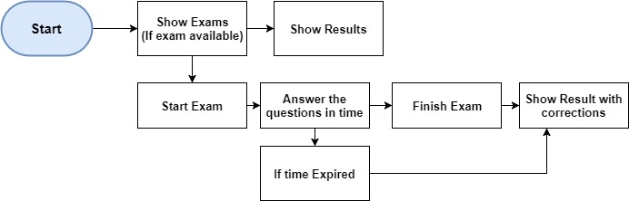

Fig: Examinee activists

**Reporting:**

QMS have the ability to download defined report with various criteria in Excel/CSV format. Reporting tools include below feathers:

* Get Exam/question into excel by wide range of shorting (Ex. Category, Subject, time range)
* Get result into excel by wide range of shorting (Ex. Individual, team wise, time range)
* Sending monthly activities report to respective person through mail.
* Easy and efficient graph interface to see exam status

**Security:**

QMS has been developed considering standard web security. The application included below points:

* Data Encryption and Transmission
  + Ability to encrypt passwords and other sensitive data based on industry-standard encryption mechanisms.
* IP addresses restriction for Admin group users should be facilitated so that only allowed work stations can be used for administration.
* Prevent parameter tampering for Data Integrity
* Passwords
  + Blocking use of certain passwords, such as easily guessed passwords, passwords based on the user ID, and passwords containing words from a dictionary.
  + Password must alpha numeric and combination of special character
  + Minimum length must be 8 characters (Alphanumeric with special characters).
  + User ID shall be locked up after "N" number (recommended to be parameterized value) of unsuccessful login attempts.
  + User ID and password shall not be same.
  + Saving passwords in to the Database is encrypted whereas while trying to login it will compare with the encrypted stored information as well as their user type/category.
  + Automatic expiration of user passwords after “N” days
  + The old password must be provided when choosing a new password.
  + Password brute forcing is prevented.
* System is able to protect itself from various application vulnerability issues like URL tampering - SQL Injection, cross site scripting etc.
* The system contains present on OWASP Top 10.

**Survey:**

* Can be online or paper based
* Online survey can be attended by external person or internal employee
* Survey can be anonymous or not
* Different types of survey should be there – different questionnaire for types of survey
* Survey result can be uploaded from excel for paper based questionnaire
* Survey result can be downloaded to excel. Survey result format needs to be discussed.
* Logical sequence of questions – Next question should be based on response to previous question’s answer

**Conclusion:**

This document introduced a user friendly designs of a web based question management system. The application is easy and convenient system for managing question and exam.